24.61: a) 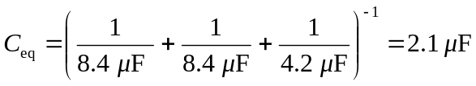
b)
c) If the capacitors are all in parallel, then:
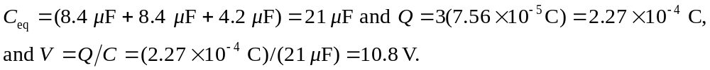
d)

